
Language Department
I.O.C/G.D.P

Reading Comprehension Worksheet
Unit 0: Nice to meet you

Name: _______________________________________________ Grade: 1st ______
Date: ___________________________ Real score: _______ Mark: ____________

Aprendizajes esperados | Comprender textos breves escritos de temas variados.  Escribir textos breves relacionados a la familia.

OBJETIVOS | HABILIDADES
OBJETIVOS | BÁSICAS: |  | INTERMEDIAS |  | AVANZADAS |  | TOTAL  PUNTAJE
 | CONOCE | COMPRENDE | APLICA | ANALIZA | EVALUA | CREA
1 Conoce estrategias de lectura que le permiten al estudiante a discriminar información Verdadera de falsa. | ITEM I  Text 1  Preg. 1 a 5  Text 3  Preg. 12 a 16 |  |  |  |  |  | 10
2 Comprende información escrita en texto breve |  | ITEM I  Text 2  Preg. 6 a 10  Text 3  Preg. 11 |  | ITEM I  Text 3  Preg. 17 a 26 |  |  | 35
3 Crea un texto sobre la familia. |  |  |  |  |  | ITEM II | 9
TOTAL PUNTAJE | 10 | 15 |  | 20 |  | 9 | 54

INSTRUCCIONES

- LEA LAS INSTRUCCIONES de cada ítem.
- Conteste con lápiz de pasta negro o azul.
- USE LETRA CLARA para las preguntas de desarrollo.

- CUALQUIER DUDA O CONSULTA COMUNIQUESE CON SU PROFESOR JEFE O PROFESOR DE INGLÉS AL CORREO dptoingles21@gmail.com

- READING

Text 1: Read the following text.

Good Morning, I am Susan Myers, I am a reporter at Central News and today I am making a report on immigrants in New York.Today´s guests are two immigrants. She is Hui Ying Lee and He is Zhao Yang. They are from China. They are Students at the community college, she is 19 years old and he is 20. They are students but they are not workers. They live in an apartment downtown.

Susan: Where are you from?
Zhao: We are from the Hubei Province
Susan: Are you happy in America?
Hui Ying: Yes, we are. We enjoy living here.
Susan: Is your real name Hui Yang?
Hui Ying: No, it’s not, it is Hui Ying, and it means smart.
Susan: Thank you very much.

They are two Chinese people living the American Dream, this is Susan Myers reporting from the Community College, and tomorrow we will have more guests in “living in America”, see you then!

Answer if following questions are True or False.

- Susan Myers is a teacher at the community College. ______
- They are from Vietnam. ______
- Zhao is a student at Harvard. ______
- Hui Ying is 25 years old. ______
- They live in the suburbs. ______

TEXT 2

My name’s Mayra and I’m Brazilian or maybe Italian, I´m not sure. It’s because my mother is from Brazil and my father is from Italy. When people ask “Where are you from?” I sometimes say “I’m from Brazil, sometimes I’m from Italy” and sometimes “I don’t know!” The problem is that I live in Brazil for most of the year but in summer, I’m in Italy with my uncle, aunt and cousins. They’re from Rome.

- Read the text and choose a title
I. A European girl. II. A Spanish girl.
III. A French girl. IV. An international girl.

- Where is Mayra’s mother from?
_____________________________________________________________________

- Where is Mayra’s father from?
_____________________________________________________________________

- Is Mayra’s uncle Brazilian?
_____________________________________________________________________

- Who is from Rome?
_____________________________________________________________________

TEXT 3
This family is very big. Abraham is the father of Homer, and Mona is mother of Homer. Herb is the brother of Homer. Marge is the wife of Homer. Her father is Clancy and her mother is Jackie. Marge has 2 sisters, Patty and Selma. Selma has a daughter called Ling. Homer and Marge have 3 children. The son is Bart and the two daughters are Lisa and Maggie.

- Complete the missing Family Tree names.
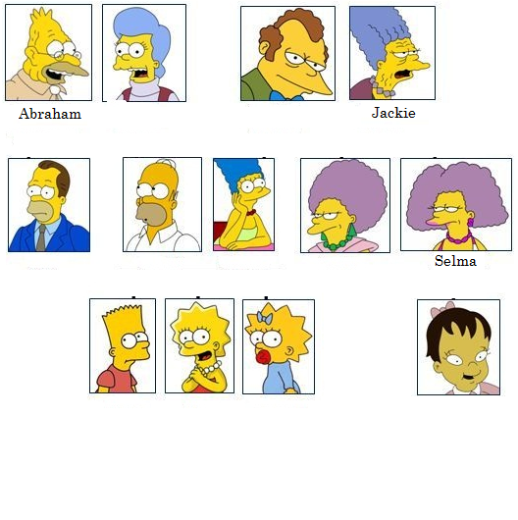

Answer if the followings statements are True or False. Correct the false ones.

- The Simpsons family is small.
_____ _____________________________________________________________

- Marge has one brother and one sister.
_____ _____________________________________________________________

- Ling is daughter of Selma
_____ _____________________________________________________________

- Homer and Marge have 3 children.
_____ _____________________________________________________________

- Homer and Marge have 2 sons and 1 daughter.
_____ _____________________________________________________________

Complete sentences with a family member.

EXAMPLE: Jackie is the __grandmother__ of Lisa.
- Ling is the ______________ of Bart and Lisa.
- Maggie is a ______________.
- Herb is the ______________ of Lisa.
- Homer is the ______________ of Marge.
- Marge is the ______________ of Patty and Selma.
- Maggie is the ______________ of Marge and Homer.
- Bart is the ______________ of Lisa.
- Marge is the ______________ of Homer.
- Abraham is the ___________________ of Bart.
- Patty is the ______________ of Maggie.

- WRITING

- Write a short introduction text about your family. Follow the text above.
_____________________________________________________________________
_____________________________________________________________________
_____________________________________________________________________
_____________________________________________________________________
_____________________________________________________________________
_____________________________________________________________________
_____________________________________________________________________
_____________________________________________________________________
_____________________________________________________________________
_____________________________________________________________________
_____________________________________________________________________
_____________________________________________________________________
_____________________________________________________________________
_____________________________________________________________________

Indicadores | 3 | 2 | 1 | 0
Uso de estructura gramatical. | Utiliza formas gramaticales en orden sujeto + verbo + complemento | Contiene hasta 2 faltas gramaticales. | Contiene de 2 a 5 faltas gramaticales | Contiene más de 5 faltas gramaticales.
Vocabulario | Contiene uso de al menos 8 palabras y conectores relacionadas con la unidad | Repite palabras y conectores con frecuencia  4-6 conectores | Vocabulario escaso y/o limitad  1-3 conectores | NO APLICA
Ortografía | No contiene faltas ortográficas. | Contiene hasta 2 faltas ortográficas. | Contiene de 2 a 5 faltas ortográficas | Contiene más de 5 faltas ortográficas.

